**Purpose:**

This document is to set up SQL Server connection in Power BI

**Scope:**

This document applies to all data analysist and epidemiologist using Power BI through SharePoint connection.

**Materials:**

|  |  |
| --- | --- |
| File Name | Location |
| Power BI Workspace | TBD |
| SharePoint | https://cdc.sharepoint.com/sites/OS/OSER |

**Prerequisites**:

* Must have Power BI Desktop
* Must have permission to use Community Group SharePoint site

**Process:**

1. Open Power BI Desktop
2. Click Get Data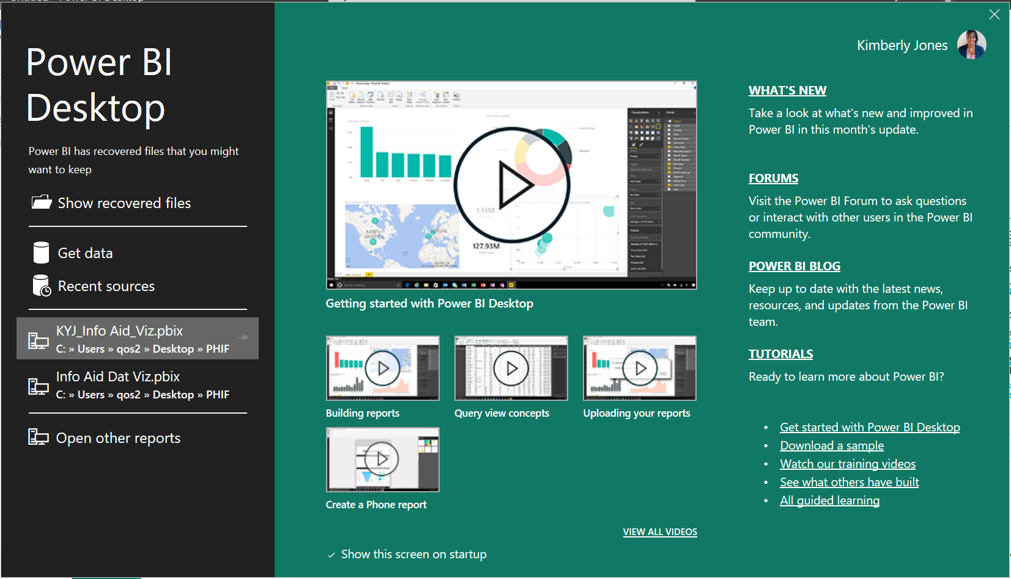
3. Search “SharePoint”
4. Select SharePoint List
5. Click Connect

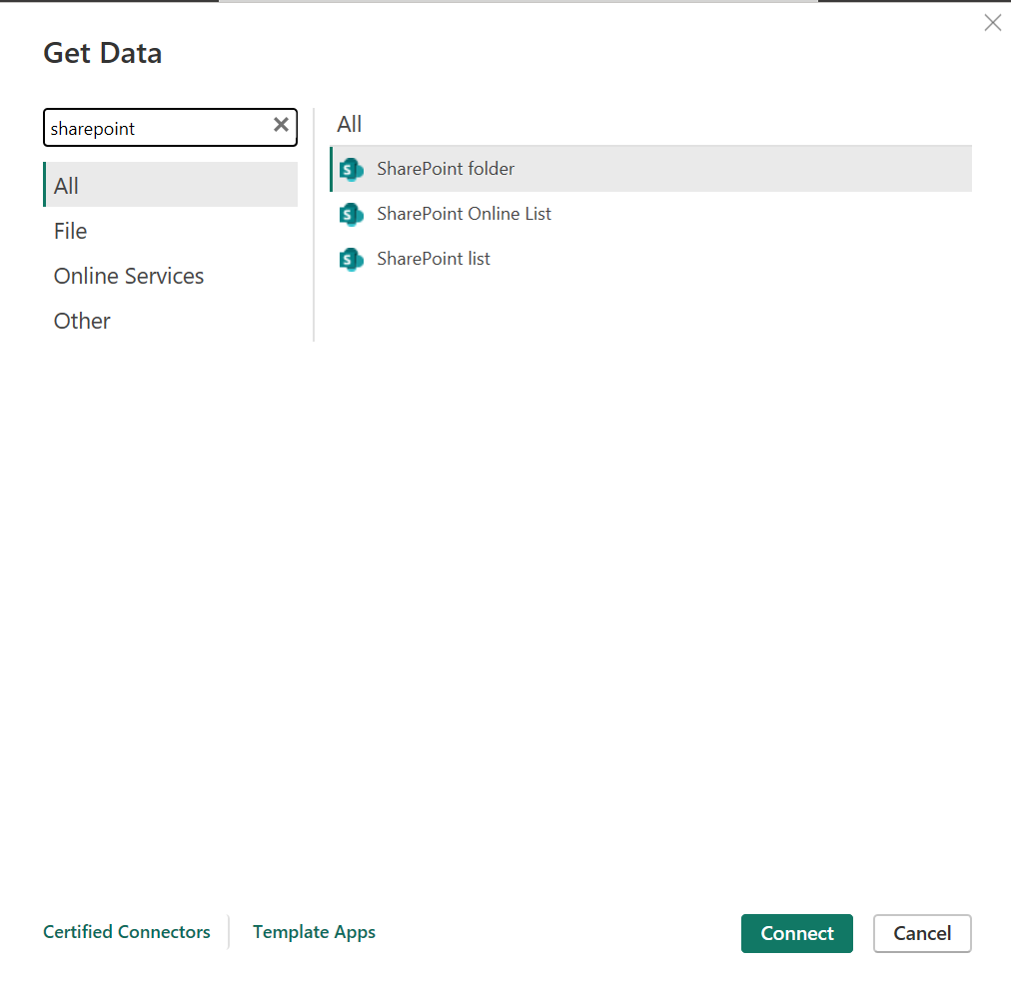

1. Enter SharePoint URL
2. Click OK

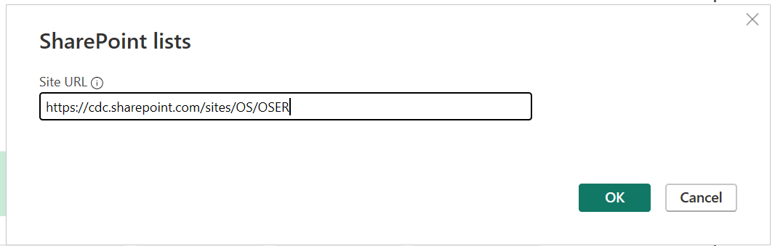

1. Load data from Community Guide Tracking Microsoft List
2. Click Load

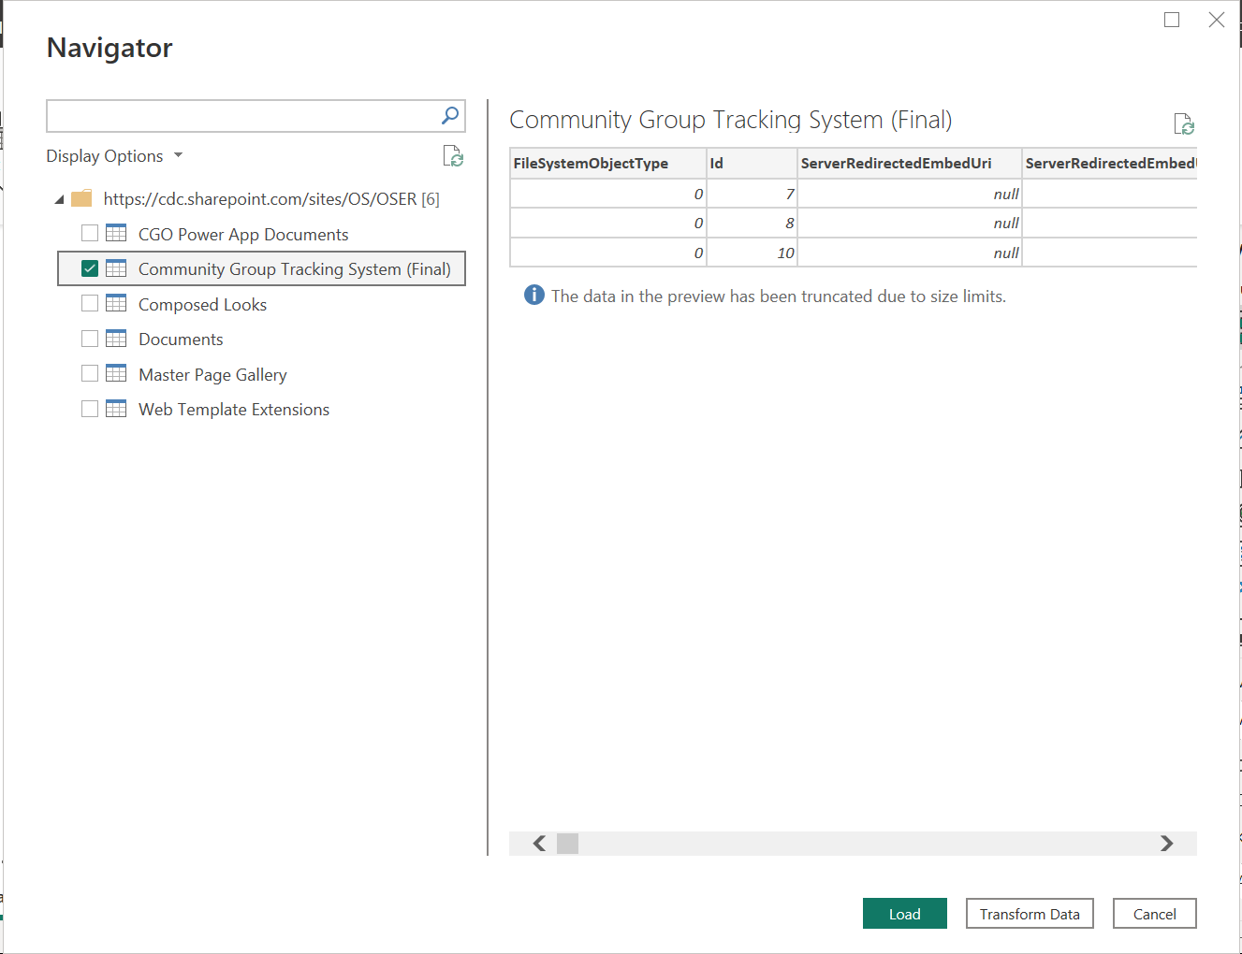

1. Power Query Editor will open to allow for edits

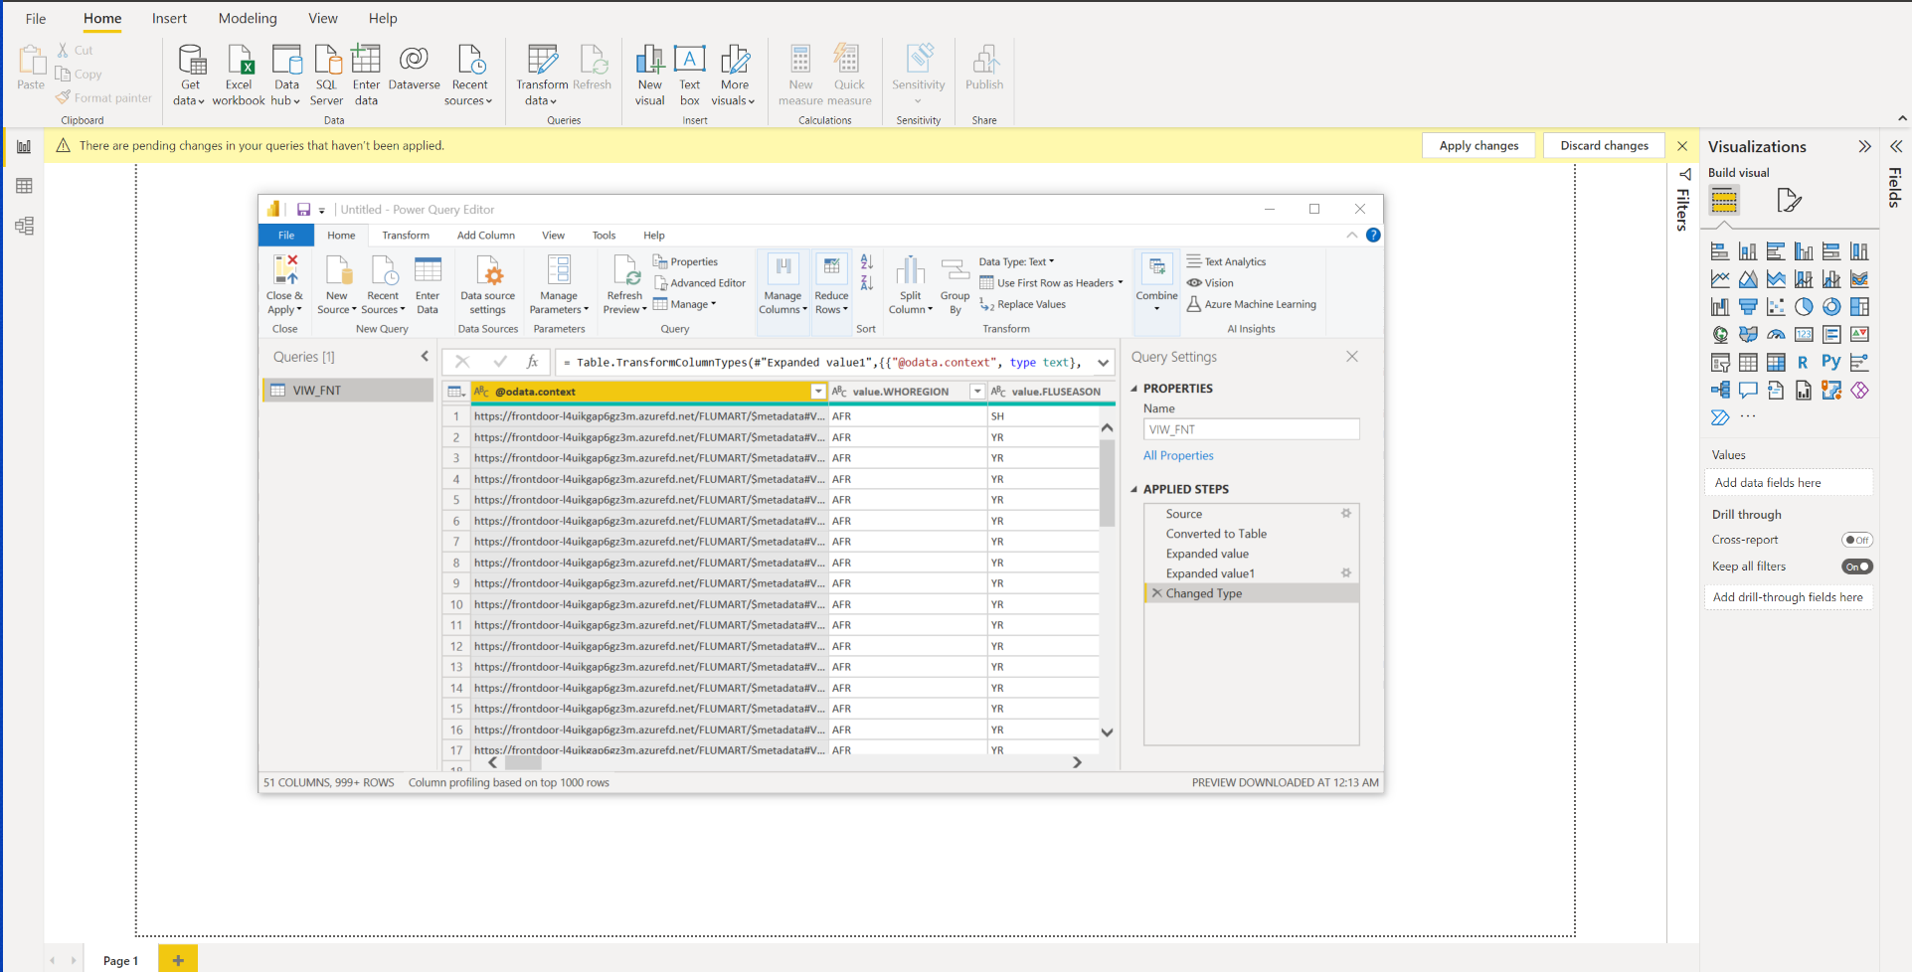

1. As you make changes you will see the changes in the right pane labeled “Applied Steps”
   1. If you have made an error click on the x next to the step to remove and start over

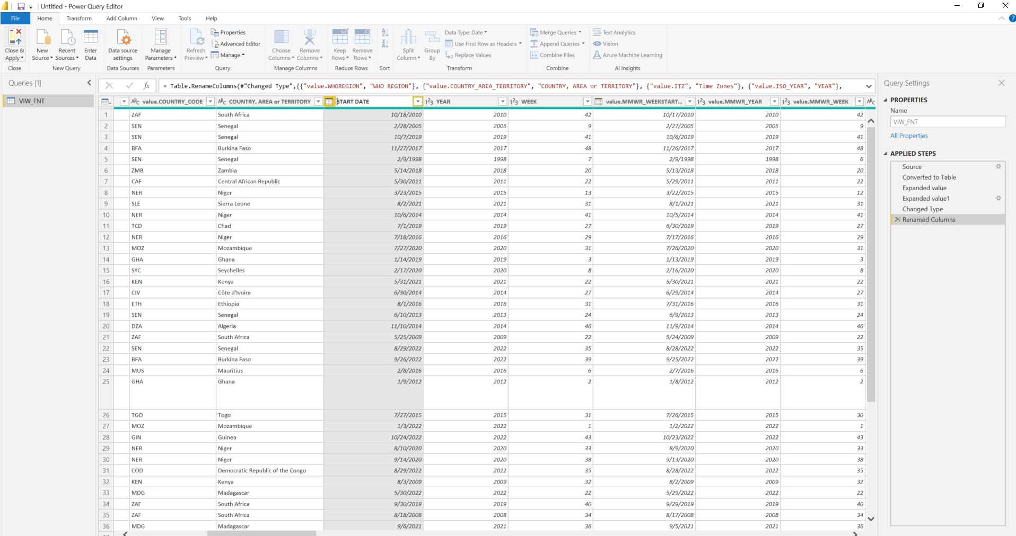

1. Click Close and Apply (Top right corner)
2. Power BI will upload and apply the changes

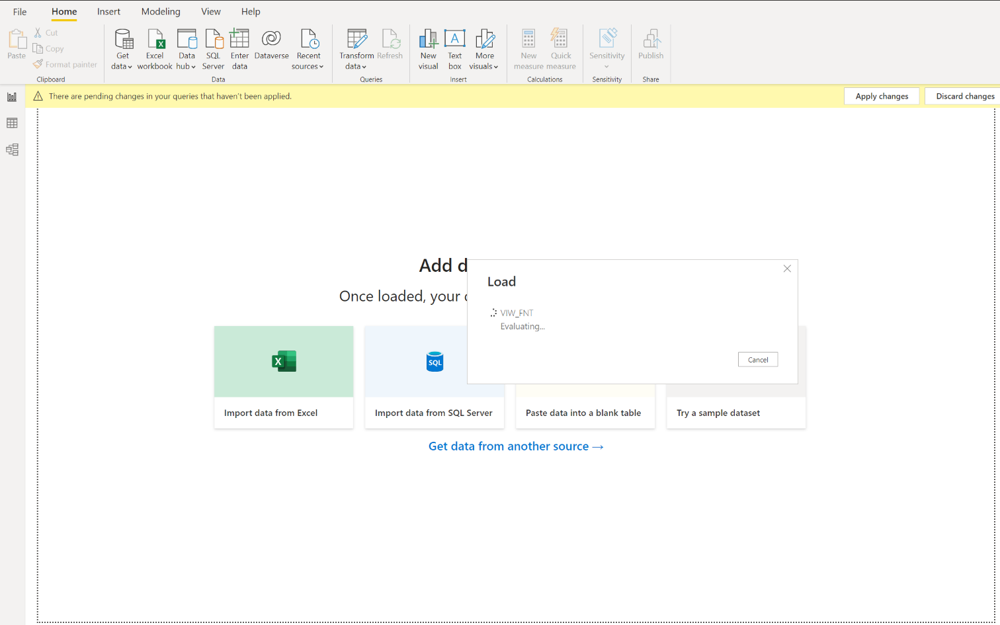

1. Click on the Report icon to the left of the screen
   1. Data will show on the right side of the screen to begin using for your models

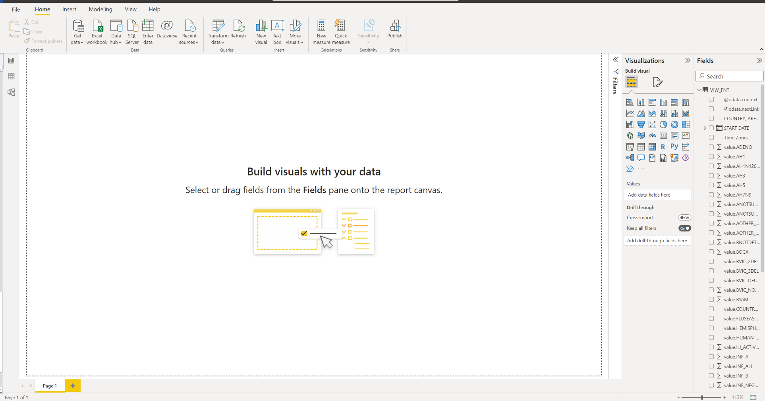

1. Click Publish

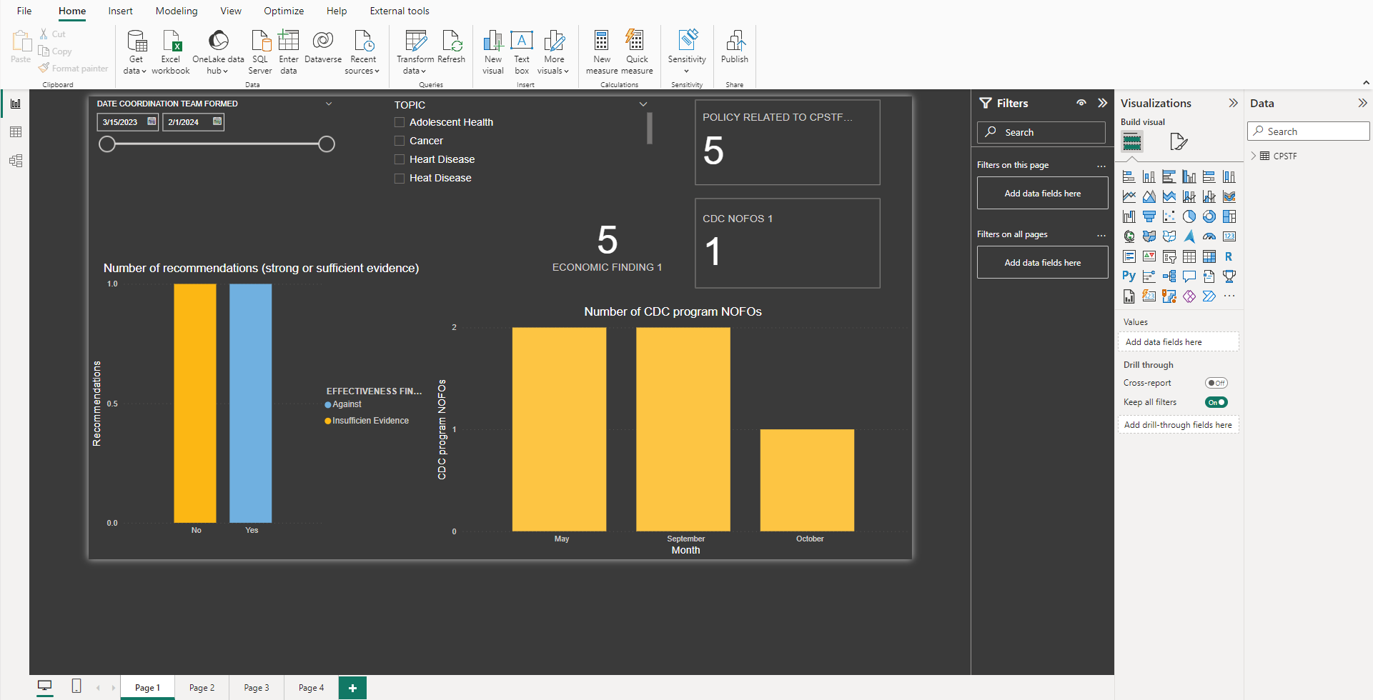

1. Select location to Publish
   1. OSER SharePoint Site

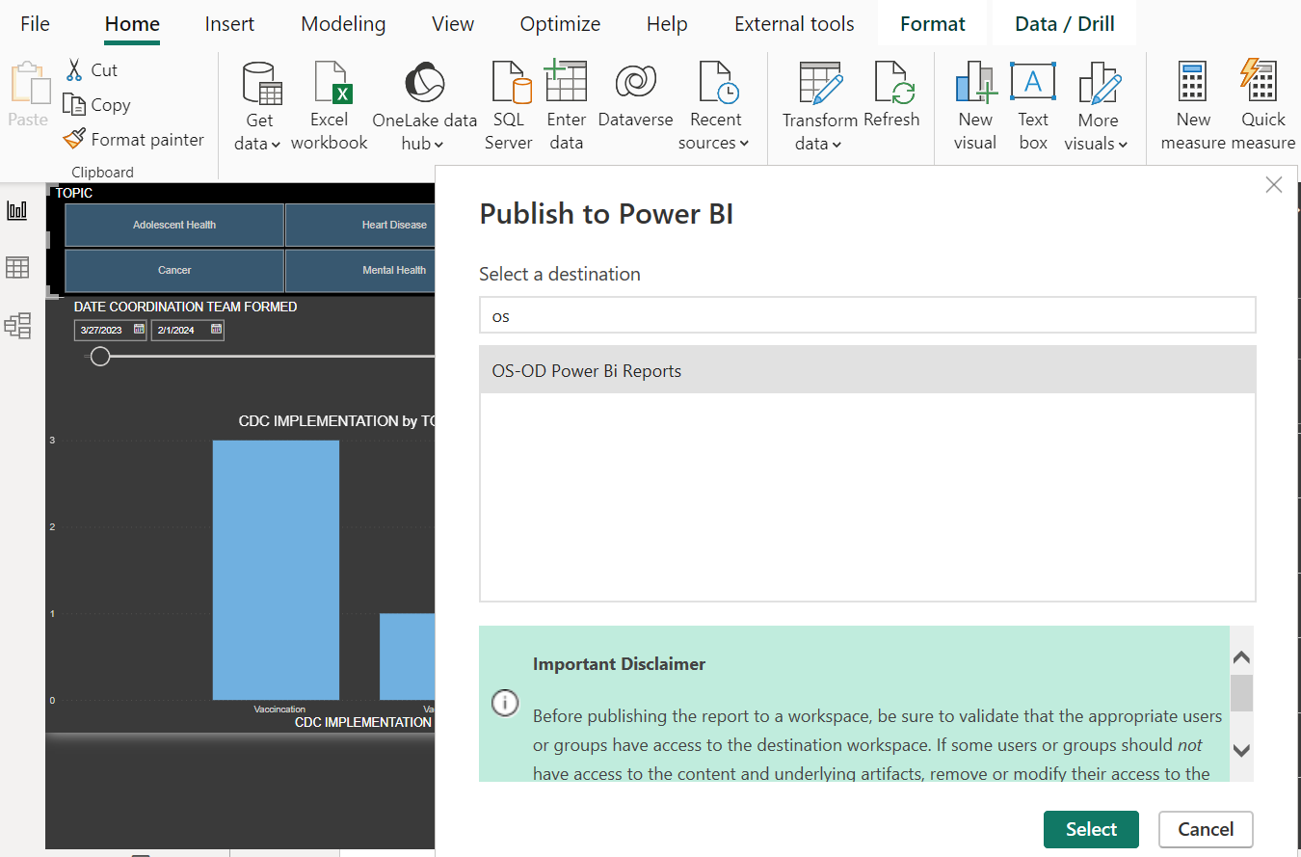

1. Select the blue hyper link

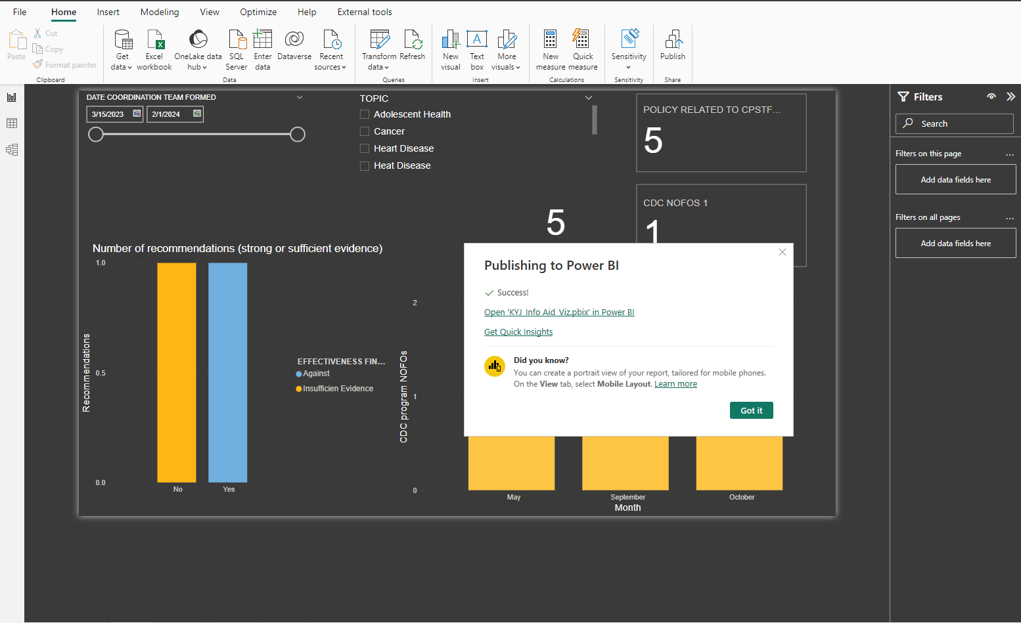

1. You land within Sharepoint workspace to view and edit reports

